**FEDERAL URDU UNIVERSITY OF ARTS, SCIENCE AND TECHNOLOGY**

**DEPARTMENT OF COMPUTER SCIENCE AND I.T.**

**(KARACHI CAMPUS)**

COURSE NAME: Design Analysis of Algorithm

INSTRUCTOR NAME: Naheed Azeem

What to Submit : A single pdf file with your name and student ID at the top.

Question: 1. What is the time complexity of the following code: ( 1 Marks each)

*int function(int n)*

*{*

*int c = 0;*

*for (i = 0; i <=n; i++)*

*for (j = i; j>=0; j--)*

*c = c + 1;*

*return c;*

*}*

*int i, j, k = 0;*

*for (i = n / 2; i <= n; i++)*

*{*

*for (j = 2; j <= n; j = j * 2)*

*{*

*k = k + n / 2;*

*}*

*}*

*void function(int n)*

*{*

*int c = 0;*

*for (i=n/2; i<=n; i++)*

*for (int j=1; j<=n; j = 2 * j)*

*for (int k=1; k<=n; k = k * 2)*

*c++;*

*}*

*void function(int n)*

*{*

*int c = 0;*

*for (i=n/2; i<=n; i++)*

*for (j=1; j+n/2<=n; j = j++)*

*for (k=1; k<=n; k = k * 2)*

*c++;*

*}*

*void function(int n)*

*{*

*int i = 1, s =1;*

*while (s <= n)*

*{*

*i++;*

*s += i;*

*printf("*");*

*}*

*}*

*void function(int n)*

*{*

*int c = 0;*

*for (i=0; i<n; i++)*

*for (j=i; j< i*i; j++)*

*if (j%i == 0)*

*{*

*for (k=0; k<j; k++)*

*print("*");*

*}*

*}*

*int i;*

*if(n%2=0) then { return “false”; }*

*else {*

*for(i=3;i<(√n)+1;i=i+2;)*

*{*

*if (n%i=0) then {return "true";}*

*}*

*} return "true";*

*}*

*int c = 0;*

*for (i = n; i > 0; i /= 2) {*

*for (j = 0; j < i; j++) {*

*c += 1;*

*}*

*}*

Question: 2.  ***21 Marks***

Use the following graph to answer the questions below.

1. Provide the DFS tree starting at node A.
2. Provide the BFS tree starting at node A.
3. Provide the DFS tree starting at node H.
4. Provide the BFS tree starting at node H.
5. Use Kruskal’s algorithm to derive the MST.
6. Use Prim’s algorithm to derive the MST starting at node A.
7. Using Dijkstra’s algorithm, determine the shortest path from node A to I. Show the steps, your tables and the resulting path.

Question: 7 ***6 Marks***

Solve this graph with Bellman Ford Algorithm.

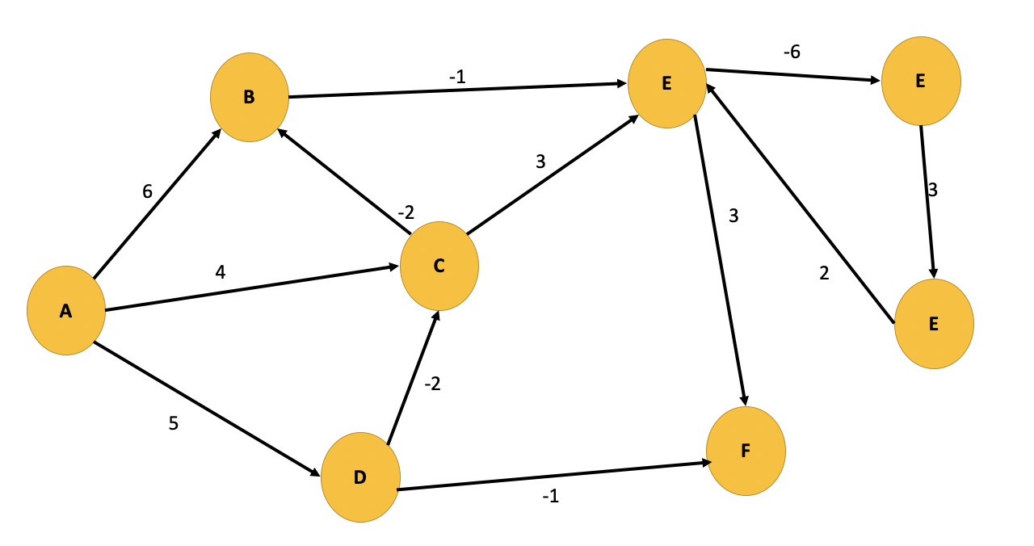



Question: 3 ***8 Marks***

Here is the data:

**yoursolutionwillbegradedforclarityandsimplicityinadditiontocorrectness**

Encode the following data with both fixed and variable length encoding. Show your complete results along with the table.

Question: 4  ***8 Marks***

1. Given some items, pack the knapsack to get the maximum total value. Each item has some weight and some value. Items are indivisible; you either take an item or not. Total weight that we can carry is no more than 15.



1. If the items are divisible what will be the profit?

Question: 5. ***4 Marks***

Consider the following table. The objective is to find a sequence of jobs, which is completed within their deadlines with maximum profit. Deadline is 5.

|  |  |  |  |  |  |  |  |  |  |
| --- | --- | --- | --- | --- | --- | --- | --- | --- | --- |
| Jobs | J1 | J2 | J3 | J4 | J5 | J6 | J7 | J8 | J9 |
| Profits | 35 | 45 | 25 | 20 | 15 | 50 | 23 | 45 | 21 |
| Deadlines | 3 | 4 | 5 | 4 | 2 | 1 | 3 | 2 | 1 |

Question 6: ***8 Marks***

Solve Travelling Salesman Problem.



***Have fun, get started early, and good luck!***

